5.49: a) Setting 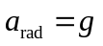 in Eq. (5.16) and solving for the period T gives
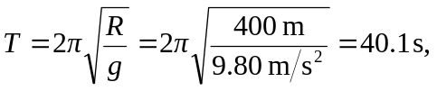
so the number of revolutions per minute is 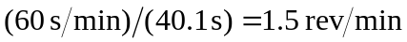.
b) The lower acceleration corresponds to a longer period, and hence a lower rotation rate, by a factor of the square root of the ratio of the accelerations, .

